

Databases and Analytics
Northstar Urban Mobility and Logistics

Module Code: CP60056E
Module leader: Shidrokh Goudarzi
Student ID: 32145186

NorthStar Urban Mobility and Logistics
Integrated Database and Analytics Report
Python Analytics, SQL-in-R Analysis and MongoDB NoSQL Implementation

Table of Contents
List of graph nd tables 1
1. Introduction 4
2. Dataset Overview and Data Quality Assessment 4
3. Python-Based Operational Analytics 5
3.1 Delivery Performance Analysis 5
3.2 Hub-Level Operational Performance 7
3.3 Manual Route Override Analysis 8
4. Customer Complaint and Service Analysis 10
5. Compensation and Financial Exposure Analysis 12
6. Incident and Delivery Relationship Analysis 13
7. Vehicle and Fleet Condition Analysis 17
8. SQL-in-R Relational Analytics 19
9. MongoDB Atlas NoSQL Implementation 20
9.1 CRUD Operations 21
9.2 Aggregation Pipelines 22
9.3 Indexing and Query Optimisation 22
9.4 Critical Evaluation 23
10. Critical Evaluation 24
11. Recommendations 25
12. Conclusion 26
REFERENCES 27

List of graph nd tables
Table 1: Dataset Structure Overview 3
Table 2: Delivery Status Distribution 5
Table 3: Delivery Performance by Hub 6
Table 4: Average Manual Route Overrides by Hub 8
Table 5: Complaint Types 9
Table 6: Complaint Severity Distribution 10
Table 7: Compensation Analysis by Complaint Type 11
Table 8: Incident Types 13
Table 9: Incident Type vs Delivery Outcome 14
Table 10: Vehicle Maintenance Status 16
Table 11: Low Battery Vehicles by Zone 17
Table 12: MongoDB Collections 19
Table 13: CRUD Operations 20
Table 14: Delivery Status Explain Plan 22

Figure 1: Delivery Status Distribution 5
Figure 2: Hub-Level Delivery Performance 7
Figure 3: Manual Route Overrides Across Hubs 8
Figure 4: Complaint Distribution by Type 10
Figure 5: Compensation by Complaint Type 12
Figure 6: Incident Distribution 13
Figure 7: Incident Types Linked to Delivery Outcomes 15
Figure 8: Vehicle Maintenance Distribution 16
Figure 9: Low Battery Vehicle Distribution by Zone 17
Figure 10: SQL-in-R Analytical Focus 18
Figure 11: MongoDB Connection Evidence 19

1. Introduction
The company NorthStar Urban Mobility and Logistics operates in multiple cities throughout the United Kingdom by offering complete logistics services and warehouse dispatch operations and passenger transport solutions and final delivery services. The company has grown rapidly yet its operations face more difficulties than before because of delivery delays and service failures and rising customer complaints and route problems and digital platform crashes and maintenance issues with its fleet. The case study identifies operational problems as direct results of system fragmentation which creates data silos that prevent managers from seeing operational processes and operational activities to respond quickly to events. The report evaluates NorthStar's operational environment through an integrated analytical framework which uses Python analytics and SQL-in-R querying and MongoDB NoSQL implementation. The report analyzes delivery reliability and hub-level performance and customer complaints and incidents and fleet condition to find structural operational weaknesses and assess how relational and NoSQL systems enable operational analytics scalability. Google Colab was used to implement Python analytics through the use of Pandas and NumPy and Matplotlib. R was used to conduct relational analysis and SQL querying through the tools of sqldf and dplyr and ggplot2. The evaluation of NoSQL document-based storage and aggregation pipelines and CRUD operations and indexing and query optimisation was conducted through the implementation of MongoDB Atlas and PyMongo. The report establishes that NorthStar suffers from operational inefficiencies which stem from interrelated systemic weaknesses that appear in multiple areas including logistics execution and customer-service coordination and digital infrastructure and fleet management systems.

2. Dataset Overview and Data Quality Assessment
The NorthStar dataset consisted of multiple operational datasets representing deliveries, orders, customers, drivers, incidents, complaints, hubs, vehicles, and digital app events.

Table 1: Dataset Structure Overview
Dataset | Rows | Columns
Customers | 650 | 9
Orders | 1250 | 11
Deliveries | 950 | 13
Drivers | 170 | 8
Vehicles | 120 | 8
Hubs | 8 | 5
Complaints | 320 | 10
Incidents | 280 | 7
App Events | 640 | 10
The dataset structure demonstrates a highly interconnected logistics environment that connects customer activities with route execution and asset monitoring and complaint escalation and operational event tracking. The preprocessing phase revealed major data-quality issues which needed to be resolved. The datasets contained various missing values which included: missing loyalty scores, incomplete booking channels, unresolved incident durations, absent delivery completion timestamps, missing compensation values and incomplete vehicle-health records
The most critical problem developed from the App Events dataset which contained 144 platform events that did not have order ID links. The evidence indicates that operational and digital systems maintain separate functions which supports the case study assertion that NorthStar systems operate as separate entities that lack analytical connectivity. The data standardization process was poorly implemented because geographical naming conventions used "WEST" and "West" and "Central" and "Ctr" and "RiverSide". The inconsistencies in data will create problems for aggregated reports while operational decisions that need zone-level analysis will suffer from reduced analytical reliability. The data required cleaning and preprocessing work which needed to be completed before the operational analytics and NoSQL aggregation work could start.

3. Python-Based Operational Analytics

3.1 Delivery Performance Analysis
Delivery reliability represented the central operational problem within NorthStar’s logistics network.
Table 2: Delivery Status Distribution
Delivery Status | Count
OnTime | 616
Delayed | 202
Failed | 132

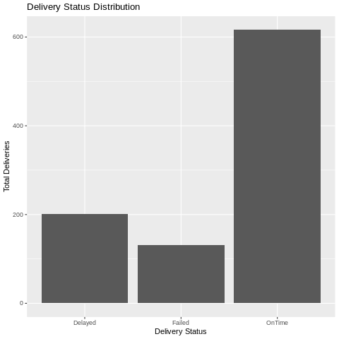
Figure 1: Delivery Status Distribution
The delivery performance data shows that 64.84 percent of shipments arrived on time while 21.26 percent of shipments experienced delays and 13.89 percent of shipments failed to reach their destination. The analysis revealed that more than one-third of all deliveries experienced operational disruption. The delivery system showed operational instability because both the delayed deliveries and the failed deliveries exceeded their normal delivery success rate. Customer satisfaction and operational efficiency both experience negative impacts from delayed deliveries while failed deliveries result in total service interruptions which lead to financial losses and damage to the company's reputation and increased customer complaints. The study results demonstrate that NorthStar's logistics systems fail to achieve proper integration between route planning and customer communication and asset allocation and operational exception handling.

3.2 Hub-Level Operational Performance
Hub-level analysis revealed substantial variation in delivery reliability across operational zones.
Table 3: Delivery Performance by Hub
Hub | Zone | Delayed % | Failed % | On-Time %
North Exchange | North | 19.12 | 12.50 | 68.38
South Link | South | 24.53 | 9.43 | 66.04
East Dock | East | 19.33 | 9.24 | 71.43
West Gate | West | 22.05 | 12.60 | 65.35
Central Core | Central | 21.74 | 20.00 | 58.26
Airport Hub | Airport | 25.96 | 14.42 | 59.62
Riverside Hub | Riverside | 21.74 | 12.17 | 66.09
Midtown Relay | Central | 17.19 | 20.31 | 62.50

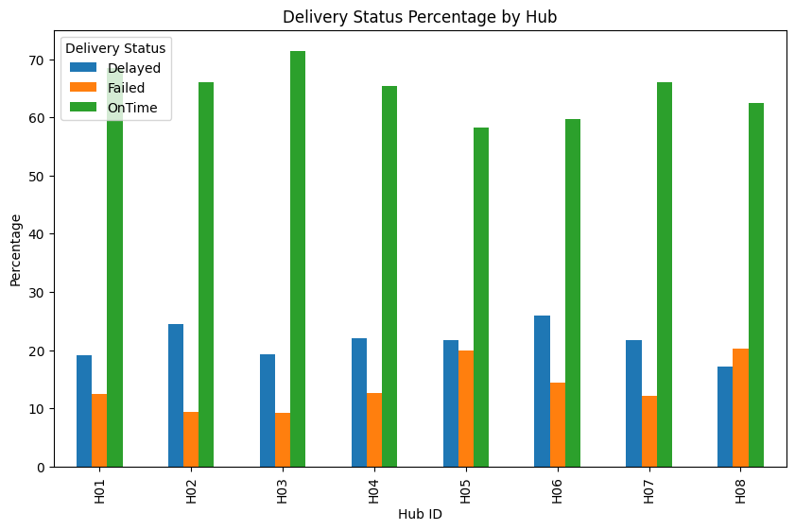
Figure 2: Hub-Level Delivery Performance
The three weakest hubs in the network were Central Core, Airport Hub, and Midtown Relay. The Central Core location showed the lowest delivery rate achievement at 58.26% while Airport Hub experienced the most delays at 25.96%.Midtown Relay recorded the highest delivery failure rate at 20.31%.
The Central-zone hub operational deficiencies indicate that NorthStar service instability occurs in specific areas rather than spreading throughout its entire operational territory. The observed patterns demonstrate that fundamental structural issues exist which stem from the operational challenges of demand management and route distribution and capacity control.

3.3 Manual Route Override Analysis
The research team used manual route override analysis to determine whether driver interventions and route management problems caused delivery instability during their driver route tracking process.
Table 4: Average Manual Route Overrides by Hub
Hub | Average Override Count
Midtown Relay | 1.11
Riverside Hub | 1.05
North Exchange | 1.03
Central Core | 0.95
South Link | 0.92
Airport Hub | 0.91
East Dock | 0.89
West Gate | 0.87

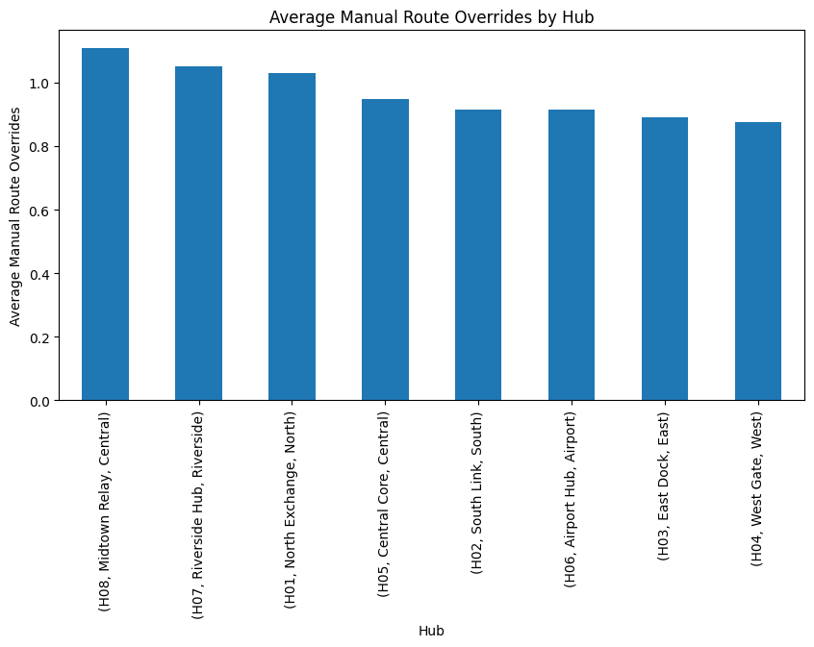

Figure 3: Manual Route Overrides Across Hubs
The highest delivery failure rate existed at Midtown Relay which also had the most delivery overrides. The data shows that service delivery problems occur because staff members make multiple route changes during their work. Central Core showed serious operational problems which appeared even though it maintained lower levels of route overrides. The data shows that route-management issues do not explain all of the performance problems that NorthStar experiences. Operational demand pressure creates additional challenges which stem from insufficient fleet capacity and staff distribution and infrastructure restrictions. The findings demonstrate that integrated analytics prove more valuable than simple single-variable explanations for understanding complex systems.

4. Customer Complaint and Service Analysis
Customer complaints provide direct evidence of how operational inefficiencies affect service quality and organisational reputation.
Table 5: Complaint Types
Complaint Type | Count
Delay | 101
MissedPickup | 64
AppIssue | 53
DriverBehaviour | 51
SupportExperience | 20
Billing | 16
Damage | 15

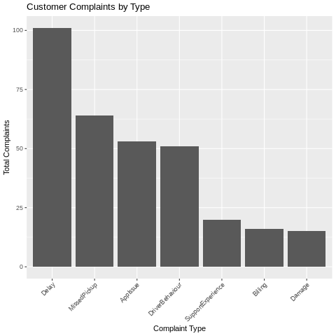
Figure 4: Complaint Distribution by Type
Delay complaints were the dominant customer issue, followed by missed pickups and application-related failures. This supports the earlier delivery analysis where substantial operational disruption was identified.
The high number of AppIssue complaints is especially important because it indicates that NorthStar’s digital infrastructure contributes directly to customer dissatisfaction. Rather than improving operational visibility, fragmented digital systems may be amplifying customer frustration.

Table 6: Complaint Severity Distribution
Severity | Count
Medium | 172
High | 77
Low | 71
The presence of 77 high-severity complaints demonstrates that operational failures extend beyond minor inconvenience and may significantly affect customer trust and long-term retention.

5. Compensation and Financial Exposure Analysis
Compensation analysis was conducted to evaluate the financial consequences of operational service failures.
Table 7: Compensation Analysis by Complaint Type
Complaint Type | Average Compensation (£) | Total Compensation (£)
Damage | 23.98 | 359.73
Billing | 23.87 | 381.94
MissedPickup | 22.59 | 1423.40
DriverBehaviour | 21.15 | 973.06
AppIssue | 19.61 | 980.72
Delay | 18.05 | 1696.84
SupportExperience | 17.13 | 342.50

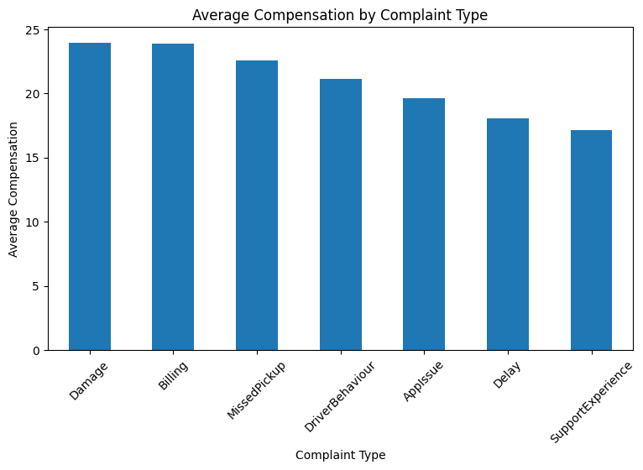
Figure 5: Compensation by Complaint Type
The total compensation costs from delay complaints created the highest financial burden while damage and billing complaints resulted in the largest average compensation payments. The financial impact of complaints depends on their frequency because their effect on finances shows different patterns. The complaint categories with lower volume create financial risks and reputational damage risks which become major problems for businesses. The findings require NorthStar to assess complaints based on operational frequency and financial impact rather than using complaint volume as their only assessment metric.

6. Incident and Delivery Relationship Analysis
Operational incidents were analysed to determine which incident categories are most strongly associated with delivery disruption.
Table 8: Incident Types
Incident Type | Count
ProofMissing | 46
CustomerNoShow | 44
RouteDeviation | 43
VehicleFault | 37
BatteryAlert | 36
AppSyncError | 31
TemperatureIssue | 29
SafetyNearMiss | 14

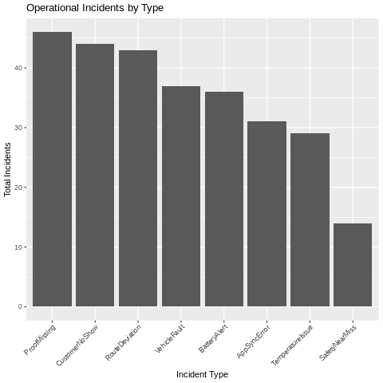
Figure 6: Incident Distribution
ProofMissing incidents were the most frequent operational issue, followed by CustomerNoShow and RouteDeviation events.
Table 9: Incident Type vs Delivery Outcome
Incident Type | Delayed | Failed | OnTime
AppSyncError | 9 | 5 | 17
BatteryAlert | 6 | 5 | 25
CustomerNoShow | 10 | 3 | 31
ProofMissing | 9 | 6 | 31
RouteDeviation | 8 | 4 | 31
SafetyNearMiss | 2 | 2 | 10
TemperatureIssue | 6 | 6 | 17
VehicleFault | 5 | 3 | 29

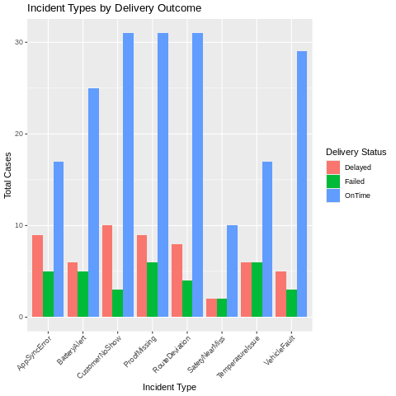
Figure 7: Incident Types Linked to Delivery Outcomes
AppSyncError incidents generated high levels of delayed and failed deliveries, demonstrating that digital synchronisation failures directly affect operational execution. Temperature Issue incidents produced particularly severe operational outcomes because equal numbers of delayed and failed deliveries were identified.
The findings demonstrate that operational incidents cannot be analysed independently because different incident categories contribute differently to delivery disruption and service instability.

7. Vehicle and Fleet Condition Analysis
Fleet analysis revealed substantial maintenance-related operational risk.
Table 10: Vehicle Maintenance Status
Maintenance Status | Total Vehicles
Active | 67
InRepair | 36
Scheduled | 17
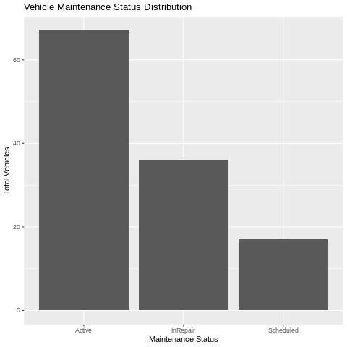
Figure 8: Vehicle Maintenance Distribution
Approximately 44.2% of NorthStar’s fleet was maintenance-constrained or unavailable. This significantly weakens operational flexibility and increases the likelihood of delivery delays and service instability.
Table 11: Low Battery Vehicles by Zone
Zone | Low Battery Vehicles
South | 8
East | 6
Airport | 6
West | 6
Central | 5
Riverside | 2
North | 2
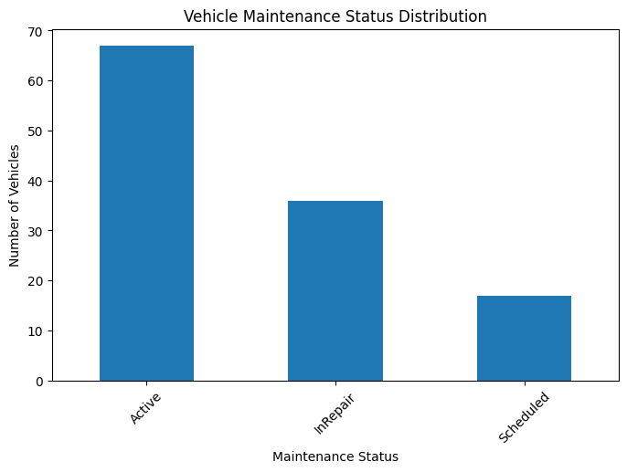
Figure 9: Low Battery Vehicle Distribution by Zone
Battery-health analysis showed that 35 vehicles fell below the 70% health threshold, with the minimum recorded value reaching only 42%.
The concentration of low-battery vehicles within South, Airport, and Central zones is especially concerning because these same operational areas also demonstrated elevated delivery instability.
The findings therefore suggest that deteriorating fleet condition contributes directly to NorthStar’s operational reliability problems.

8. SQL-in-R Relational Analytics
SQL querying was implemented in R to analyse structured relationships across NorthStar’s datasets. This stage helped test whether delivery delays, hub weaknesses, complaints, incidents, compensation and vehicle-maintenance problems were connected rather than isolated.
Figure 10: SQL-in-R Analytical Focus
Area | Purpose
Delivery status | Measure on-time, delayed and failed deliveries
Hub performance | Identify weak operational locations
Complaints | Link customer dissatisfaction to service problems
Compensation | Assess financial exposure
Incidents | Connect incidents with delivery outcomes
Vehicles | Assess fleet availability risk
The SQL-in-R analysis found that NorthStar's operational problems are interconnected with its operational activities. The results showed that service disruptions occurred in particular areas, while the incident-delivery results demonstrated that specific incident types caused more delivery failures than other incidents. SQL demonstrates diminished performance for recording flexible data types which include app events and complaint histories and route exceptions and evolving incident logs. The records contain information which changes and information which should be stored in NoSQL document databases. The decision to use MongoDB Atlas resulted from these requirements.

9. MongoDB Atlas NoSQL Implementation
The testing used MongoDB Atlas to determine if NorthStar could operate flexible data using a document-based database. The database successfully connected to Google Colab through PyMongo after the connection process..
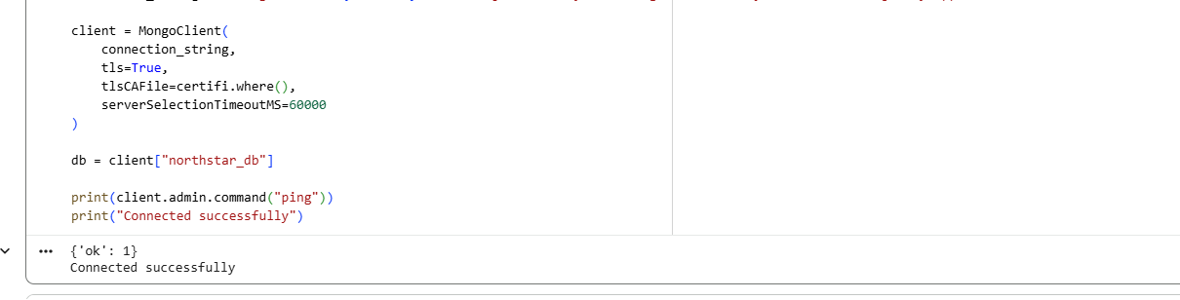

Figure 11: MongoDB Connection Evidence
Table 12: MongoDB Collections
Collection | Records
customer_documents | 650
order_documents | 1250
delivery_documents | 950
driver_documents | 170
vehicle_documents | 120
hub_documents | 8
complaint_documents | 320
incident_documents | 280
app_event_documents | 640
MongoDB was suitable because NorthStar’s incidents, app events, complaints and exceptions are more flexible than standard relational records.

9.1 CRUD Operations
CRUD operations were completed to show that MongoDB can manage live operational records.
Table 13: CRUD Operations
Operation | Method
Create | insert_one()
Read | find_one()
Update | update_one()
Delete | delete_one()
This is relevant because logistics records are constantly created and updated, including complaints, delivery events and incident statuses.
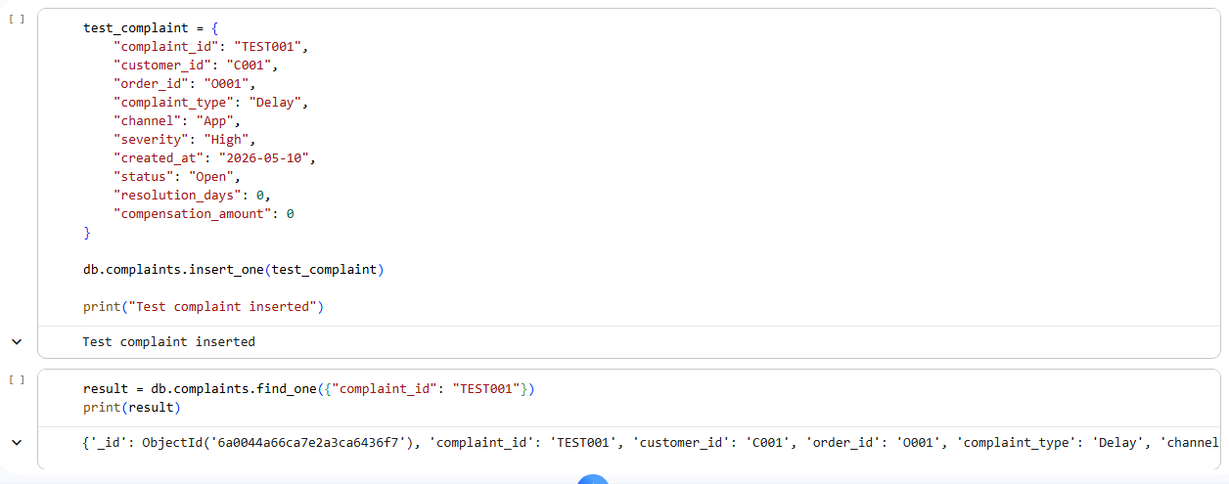


9.2 Aggregation Pipelines
MongoDB aggregation pipelines were used to summarise: delivery status; complaints; compensation; vehicle maintenance; incidents; hub delivery risk. The $lookup function was especially useful because it linked incidents with delivery outcomes using delivery_id. This showed how MongoDB can support integrated operational analysis rather than isolated document storage.

9.3 Indexing and Query Optimisation
Indexes were created on key fields such as:
Field | Purpose
delivery_status | Fast delayed/failed delivery searches
hub_id | Hub-level monitoring
complaint_type | Complaint analysis
incident_type | Incident tracking
maintenance_status | Fleet availability monitoring
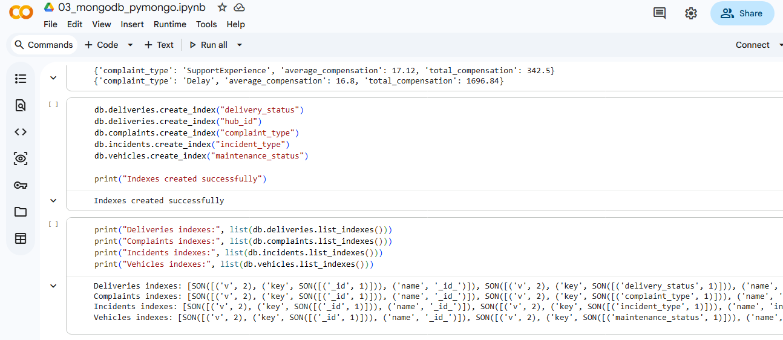
Table 14: Delivery Status Explain Plan

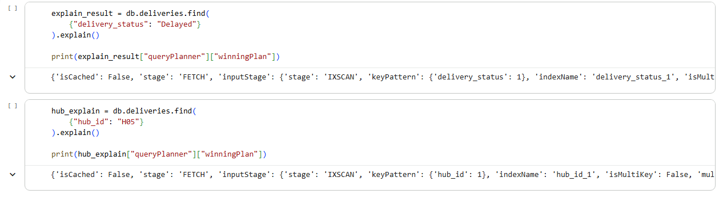
The evidence demonstrates that MongoDB utilized indexes for data retrieval instead of doing full collection scans. NorthStar achieves better operational monitoring through its ability to handle increasing data volumes.

9.4 Critical Evaluation
MongoDB enabled greater flexibility for handling semi-structured data formats which included application events and incident reports and complaint records. The system lacks the ability to address existing data quality issues. Organizations need to manage missing values and inconsistent zone names and weak identifiers. NorthStar needs to operate its stored data through relational systems which handle structured records while MongoDB handles flexible operational event data.

10. Critical Evaluation
NorthStar operational weaknesses become visible through the Python, SQL-in-R, and MongoDB framework which connects different delivery systems and complaint-handling systems and incident response systems and fleet condition monitoring systems and digital system operations. NorthStar operational architecture needs to address two major architectural deficiencies which prevent effective operational management.
• fragmented data governance;
• disconnected digital systems;
• inconsistent operational records;
• weak standardisation;
• limited operational visibility.
Relational systems provide essential support for structured reporting and data aggregation while MongoDB enables flexible handling of semi-structured operational environments that include app events and incident reports and route exceptions and changing logistics records.
The NoSQL flexibility permits organizations to create governance structures which require their data to follow predetermined rules. Data-quality issues required extensive cleaning because missing compensation values were the only values available for aggregation.
NorthStar needs to develop better technological capabilities while establishing stronger data governance practices and unified analytical frameworks for their organization.

11. Recommendations
NorthStar needs to adopt an operational analytics framework which connects relational systems with NoSQL systems into a unified analytical platform for their business. The organization needs to configure their databases to permit relational databases to handle all structured transactional reporting while MongoDB operates as their semi-structured operational event system which handles all exception data from their operational environment.
The organization should prioritize:
• operational data standardisation;
• integrated customer and logistics reporting;
• predictive fleet-maintenance analytics;
• route-optimisation systems;
• real-time operational dashboards;
• digital-platform synchronisation;
• automated data-quality validation.
The operational capabilities of fleet-maintenance programs need improvement because vehicle deterioration leads to service outages. Organizations can achieve better delivery performance through predictive maintenance models which help them predict equipment failures.
The operational activities between Central Core, Midtown Relay, and Airport Hub need to be synchronized because those areas display higher operational hazards.
The organization needs to implement digital event logging governance and application integration control systems because fragmented digital systems create obstacles to delivering better customer service and maintaining operational visibility.

12. Conclusion
The research evaluated NorthStar Urban Mobility and Logistics through Python analysis and SQL-in-R queries and MongoDB NoSQL applications. The analysis demonstrated that NorthStar’s operational problems are interconnected across deliveries, customer complaints, incidents, fleet condition, and digital infrastructure.
The investigation revealed multiple delivery system problems which occurred throughout various delivery routes and transformed high customer dissatisfaction into an ongoing operational incident pattern which resulted in maintenance-related vehicle risks. The report demonstrated that operational systems create obstacles to managerial control while operational system inconsistencies prevent accurate analysis of organizational performance.
The analysis through Python and SQL-in-R provided operational performance insights which revealed relational relationships. MongoDB Atlas enables organizations to utilize its document-based analytical system for handling semi-structured logistics data.
NorthStar needs to establish operational governance systems and create analytical infrastructure systems while developing stronger data quality management capabilities to achieve better organizational performance.

REFERENCES
Elmasri, R. and Navathe, S. (2017) Fundamentals of Database Systems. 7th edn. London: Pearson.
Han, J., Kamber, M. and Pei, J. (2022) Data Mining: Concepts and Techniques. 4th edn. Cambridge: Morgan Kaufmann.
MongoDB Inc. (2025) MongoDB Documentation. Available at:
MongoDB Documentation (Accessed: 10 May 2026).
Pandas Development Team (2025) Pandas Documentation. Available at:
Pandas Documentation (Accessed: 10 May 2026).
Wickham, H. and Grolemund, G. (2017) R for Data Science. Sebastopol: O’Reilly Media.
University of West London (2026) Databases and Analytics Assignment Brief.
University of West London (2026) NorthStar Urban Mobility and Logistics Case Study.

